- Build data set - Ashish
  - Source material
    - First person accounts?
      - -Tanika Williams-
    - Historical records
      - Secrets of 370 Jay Exhibition
      - Transit Museum
    - NYU informationals

TIME CAPSULE - buried in 1950, opened in October 2014 - NY Daily News
A time capsule buried at the former NYC Transit Headquarters in Brooklyn in 1950 proved to be just like the subway: porous, leaky and rusty.
There was a nickel, some badly deteriorated newspapers and a glass box that was believed to have microfilm of the original construction drawings of 370 Jay St. that experts believe won't be salvageable

Experts on hand said nothing in the time capsule appeared salvageable — except for a nickel.

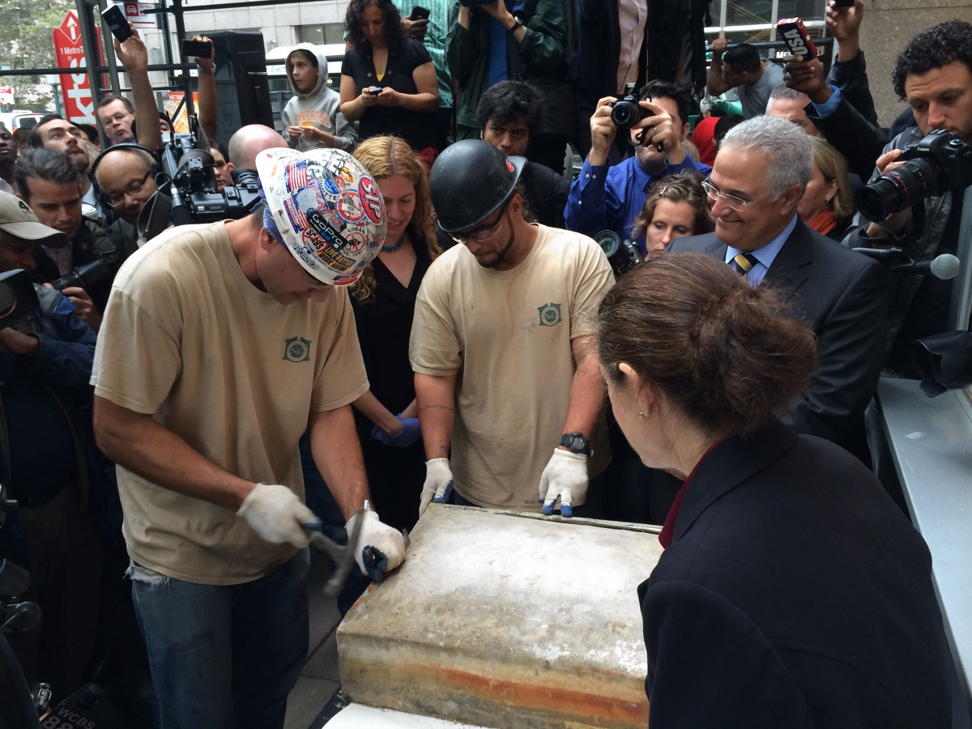

Steelwork completion in 1949, Mayor O’Dwyer alleges that Transit Unification in 1940 was a dirty deal. Brooklyn Eagle
O'Dwyer attacked the unification deal that had been completed under his predecessor, La Guardia.
He stated it would cost city’s taxpayers 700 million rather than the originally stated 300 million, with the additional 400 million to be paid out over the next 40 years to bond holders who have been guaranteed a 3% tax exempt return on their investment.
His comments were likely a distraction from the growing police scandal surrounding his own administration.

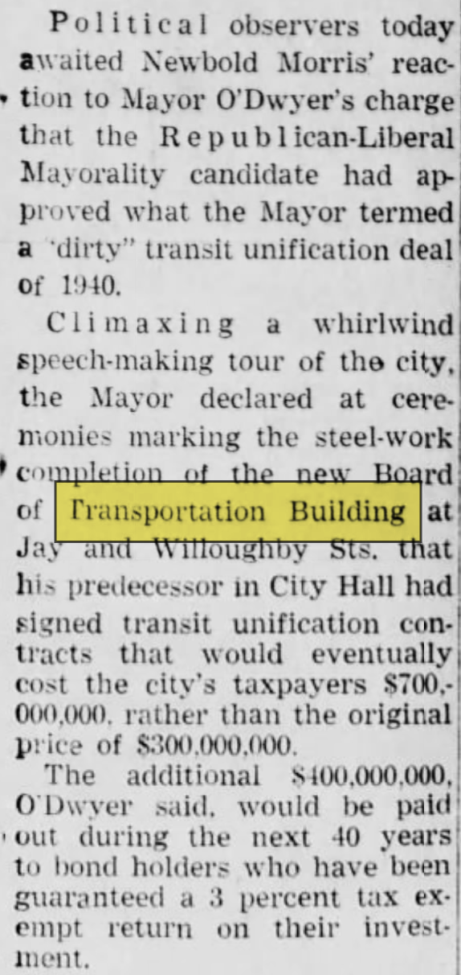

Untapped Cities 370 Jay Street was built in 1951 as part of the post-World War II Brooklyn Civic Center Urban Renewal project.

The building once had cool aspects such as a secret second floor elevator used to transport money, the Subway Command Center, and a Lost and Found Department containing abandoned umbrellas.

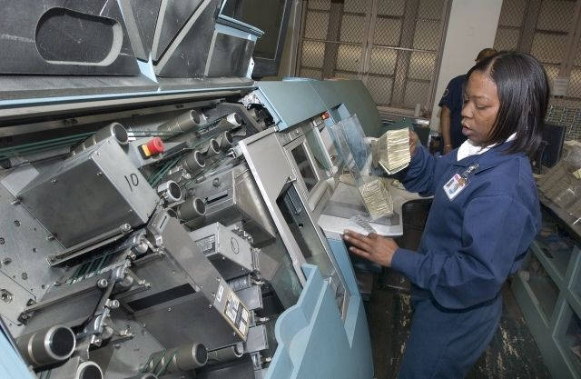
A Money Room employee uses the GPS 1000 high speed mixed currency counter and sorter to process 30 bills per second, 2006. Credit: Patrick Cashin / MTA New York City Transit

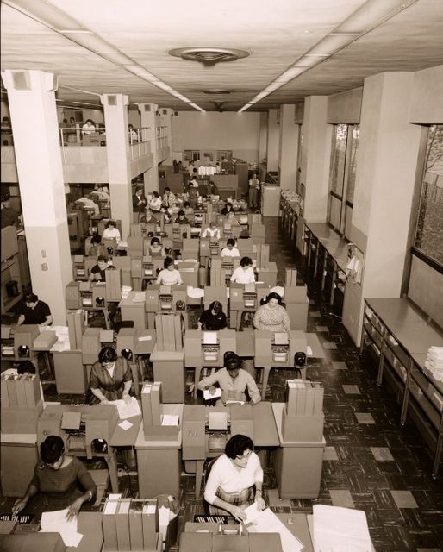
Another view of the crammed data processing rooms, 1957. Courtesy of the New York Transit Museum

In 2012, New York University and the city of New York agreed to renovate the building into a sustainable hub for NYU’s growing engineering programs.

Brooklyn Eagle

October 2015 - “The Secret Life of 370 Jay Street” will reveal the inner workings and the quirky history of one of New York’s first mid-century modern office buildings.

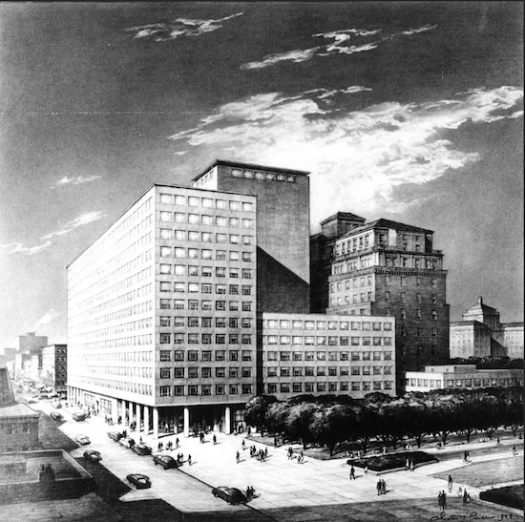
Rendering from the Board of Transportation Annual Report, 1949. Photo courtesy of the New York Transit Museum

Its 420 perfectly uniform windows hid a secret elevator used to move cash from fare collection trains to the Money Room on the second floor.

In 2012 the City of New York and New York University entered into an agreement to transform 370 Jay St. into a modern, sustainable academic center that will be the foundation of the University’s expanding engineering and applied sciences programs, including their Center for Urban Science and Progress

aiany.org - The 370 Jay Street project is three stories in one: the LEED Platinum renovation of a mid-century building with sustainability as a key goal; advancement of a new academic trajectory for a leading university; and a partnership between the University and the City.

Altas Obscura
Falling into disrepair - The Brooklyn Eagle shortlisted it as one of the borough’s ugliest buildings. And, as a 2012 New York Times piece about its renovation noted, “it is pretty much impossible to love the Transportation Building.”

HEIST! - One Saturday morning in 1979, there was a planned blackout at 370 Jay as part of a drill. Even though extra guards were posted at the Money Room, the robbers got their way. “Monday morning, people walk in, they open the vault, and $600,000 is missing,” Harmon says. All of the ten-dollar bills were gone, 120 pounds worth.
Officials scrambled to figure out what happened.
They found an escape hole in the wall of the adjacent women’s bathroom and tracked the thieves to a hotel room in New Jersey, where they found an empty bag marked “Transit Authority.” After an initial investigation that reportedly focused on someone inside the transit agency, officials eventually put out a $25,000 reward to catch the suspects. But they were never caught and the money was never returned.
The elaborate fare collection apparatus wasn’t the only way 370 Jay Street’s form mirrored its function. It had entire rooms dedicated to phone equipment with people who manually connected calls.
Lost and Found Items - It housed a lost and found, which saw hundreds of umbrellas, tubas, a pheasant, and a jar full of ashes labeled “my dear wife Ada.”

https://nyu.manifoldapp.org/read/runbin-final-project/section/894372bb-92ce-40f9-bcb0-4a969522c460

The building was designed not only to consolidate more than fifty departments but also to streamline fare collection by allowing collection trains to run directly into the structure. This would eliminate the need for armored trucks to transport fare boxes through city streets. The relocation was part of a broader effort by Mayor Fiorello La Guardia to decentralize city agencies and distribute municipal functions more evenly across the five boroughs (The New York Times, 1939)

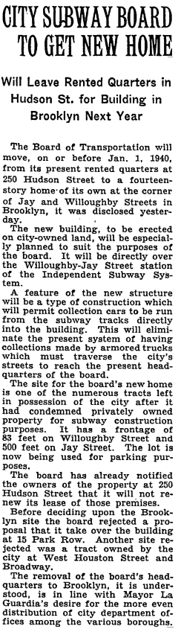

The plan of 370 Jay Street started around 1940. At that time, a newspaper article reported that the New York City Transit Board wanted to build a new office building in Brooklyn. The plan was to construct a 15-story structure that would cost $3.8 million(Based on BLS estimates, $3.8 million in 1940 would be worth nearly $87.5 million in today’s dollars). The building was intended to serve as a central office for the city’s transit system (Brooklyn Daily Eagle, 1940).

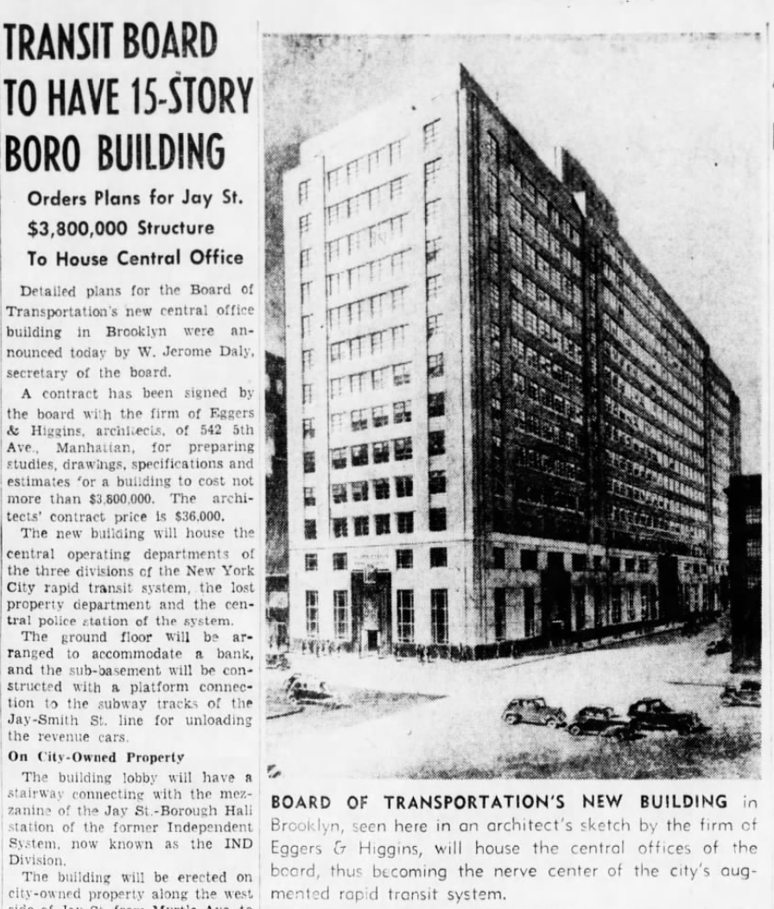

During World War II, the construction of 370 Jay Street was significantly postponed as a direct consequence of wartime mobilization. The federal government imposed strict rationing policies on essential construction materials, especially steel, copper, and concrete, which were redirected to support military production such as ships and aircraft. Civilian building projects across the country, including the planned headquarters of the Board of Transportation in Brooklyn, were considered nonessential and had to be delayed. At the same time, the labor force was reduced because many skilled workers were drafted or voluntarily joined the armed forces. Others shifted to wartime industries such as weapons manufacturing and shipbuilding. These combined shortages of materials and labor made it impossible for the BOT to move forward with construction during the war. It was only after the conflict ended, when materials became available again and the construction workforce returned, that the project resumed in 1948.

The original budget had nearly doubled to $7 million(Based on BLS estimates, $7 million in 1948 would be worth nearly $94.5 million in today’s dollars), and the number of floors was reduced to 13 (The New York Times, 1948). Construction began in the summer of that year.

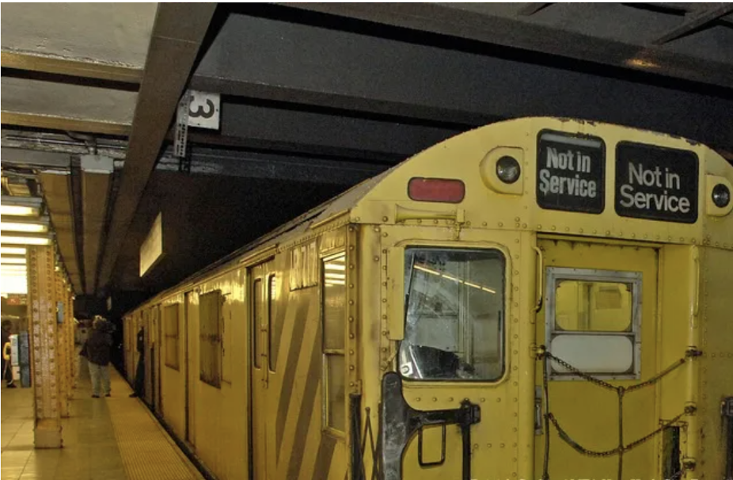
Money Transit Train Used at Jay Street Station

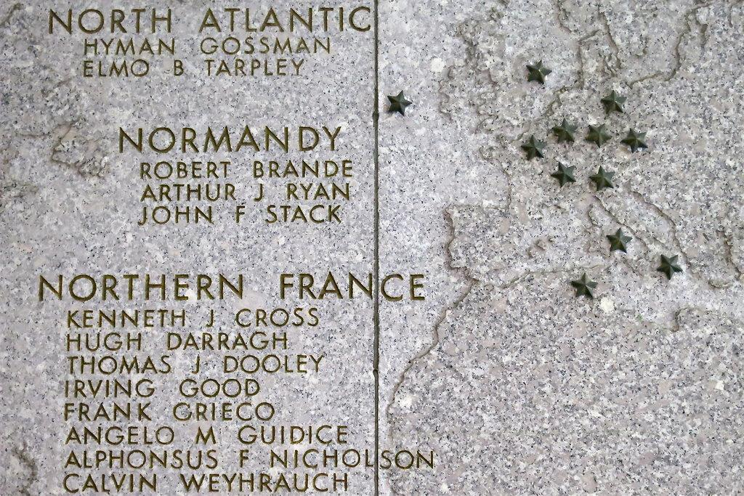

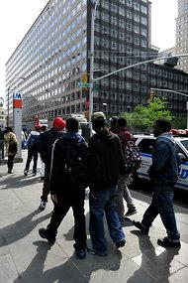
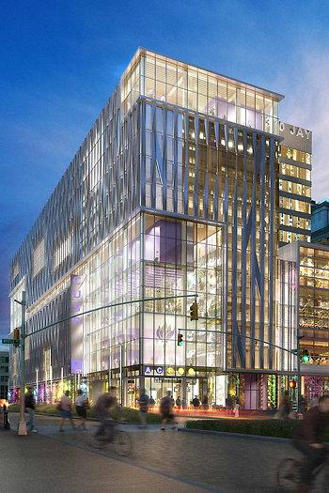
Questions for Tanika:

Archival Resources

Blueprints

